Kapadia, Hasan

H00289018

Abstract

The Report contains an analysis of the domain and problem files submitted  
and will contain thorough explanation on the code written

pddl report

F29AI CW

# Domain Code Analysis

The Domain Code shows every action needed to complete the given scenarios.

The code design was based on what each scenario asked for without being broken down into multiple actions except for major actions such as: Moving and Ordering.

The layout of the submarine given in the code is:

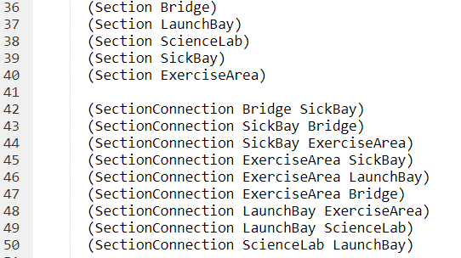

Where Sections shows that the submarine has 5 sections and the SectionConnection shows how the layout of the submarine is:

The underwater regions have been labelled as:

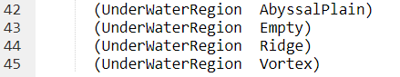

Where each region is been assigned to the tag UnderWaterRegion

The additional feature I added was a trainer who trains the staff onboard the submarine in the exercise area

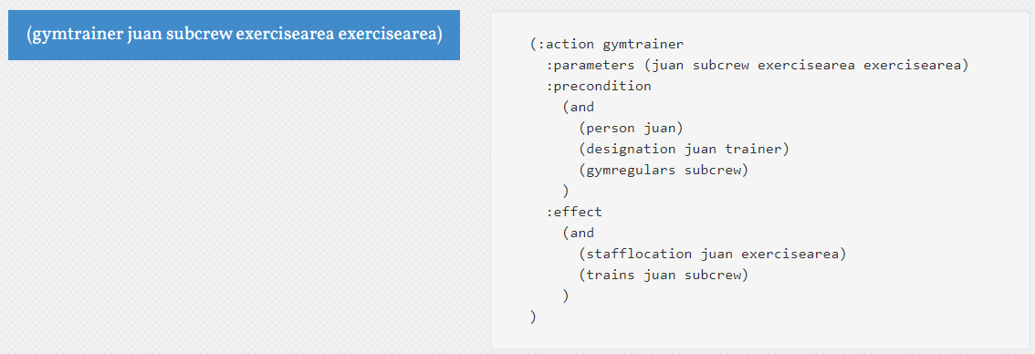

This code basically takes the conditions that there is a person who’s designation is a trainer and there a group of crew that are gym goers and when in the gym Juan (Trainer) can train the crew.